Dear W..

Today is 0604, it is 2347 Now.

I had many things to say but forgot what to write now.. Anyway.. I need to start talking to you..

1. I usually talk to you every day and all the time in our QQ. However I don’t receive any response. Today QQ also has congratulated us to complete our 6 years of relationship.

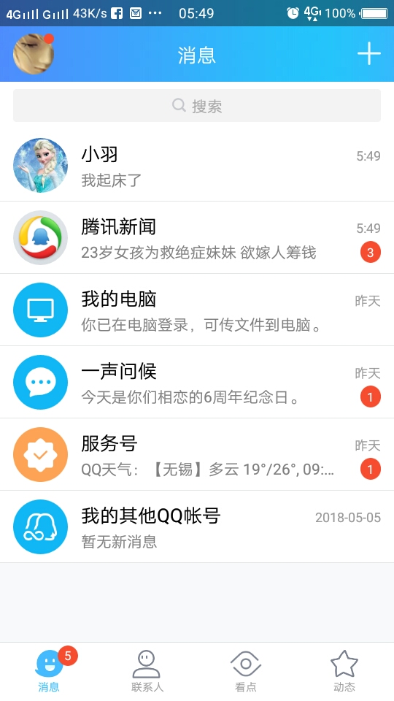

1. Here is our initial photos.. when we used to talk until late night..



1. Our dream home was here..

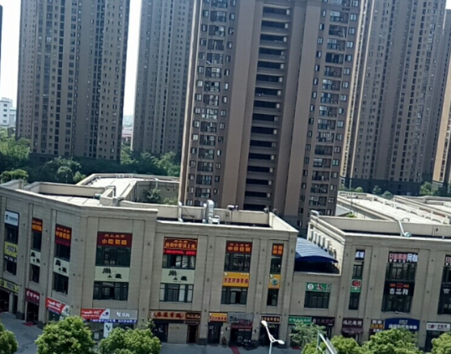

1. 断桥-杭州

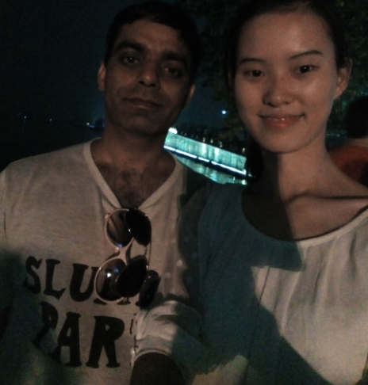

1. My last day at work.. May 19, 2017.. We dinner in Indian hotel.

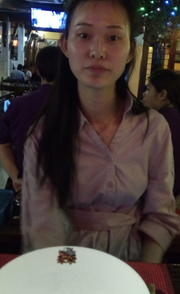

And many more.

About me: How am I? Usually I am calm and silent. Often I chat with you in our QQ and talk to your photo. I have our wedding ring, your hat, I make sure to keep them safe.

**关于你**:你是我的永远的老婆。I am still living with you and die with you. I have hope we will meet again. Destiny will bring us together. If not, I will not blame anyone.

**关于生意**：我慢慢开始了. I am doing better. If one day we meet in future or I go without meeting you. I want to keep my promise to you. And one day everything will leave here.

**关于结婚或者她** After our marriage (0604) I did not keep in touch with any girl. In September last year i talked to 沈芳 after many years. Even though there are some chances to live with Chinese girl or marry Indian girl. My family recently found many girls. But I have denied to my family. In this life ONLY YOU. 她也没有出现了。她不会打扰我.

**ME:** 现在我是一个平静和无声的人。我不想反对这个世界。我还是学汉语，学习Business Studies。起床0530，睡觉0000 或者0030 点钟。

1. One day your BF came to my dream, he complained to me that you are not going for exam to Bangalore and spend more money. Then I talked you over phone， asked you to save money and go Bangalore for test. You said, “OK I will go”. This was the last time I heard your voice in dream.
2. We watched 3D movie on 投影机in WX. That was the last movie of my life. 还有更多东西变了。 你还是在我的生活. Thanks for your love, care and everything. Give my love, care and respect to all people around you. Also love to our BABY.
3. 亲爱的老婆请 继续your life. 终于我就想你的好好生活，无论我在不在。It’s all is destiny命运, and nothing else. **One day I will go from here, but I will not stop loving you.** I accept your hate, love and everything.

现在0200（06月05日）。0530我要起床了。我都没有任何问题或者抱怨，只有祝福和感谢。你 永远在我的生活。Please forgive me for many things.

I might keep visiting your place without disturbing or informing you. Later in life I wish to die near you.

**亲爱的老婆爱你，我们会再见面”一生一世”.**

**Your BIG BAD BALU**